# Exercise 5 - Exploring JMP Samples

This exercise will help you to open some samples of various kinds in JMP and explore some of the functionality.

1. Open Sample Data Index using Help/Sample Data  
   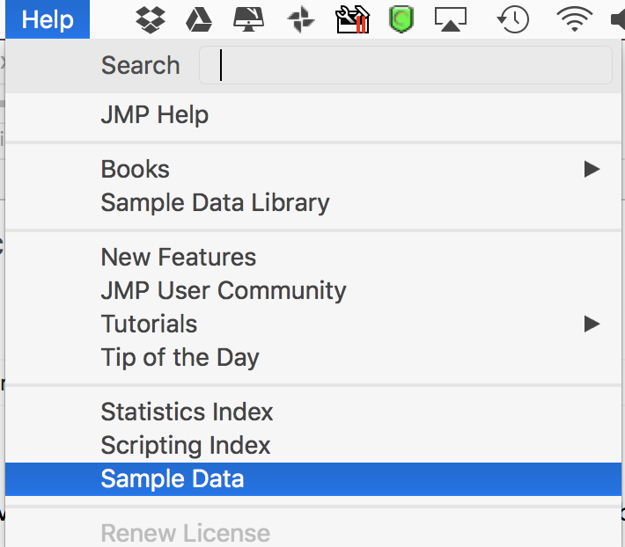
2. Click on the top 4 buttons and try some of the content by clicking on it. Then double click to open any of them up.  
   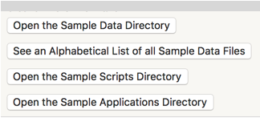
   1. Sample Data Directory  
      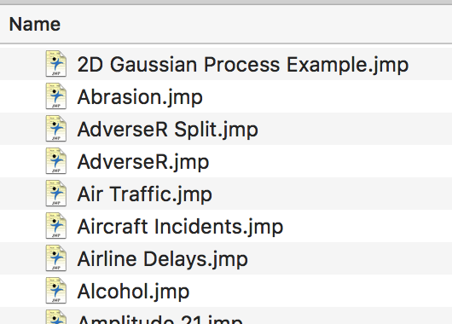
   2. Alphabetical List of all Sample Files  
      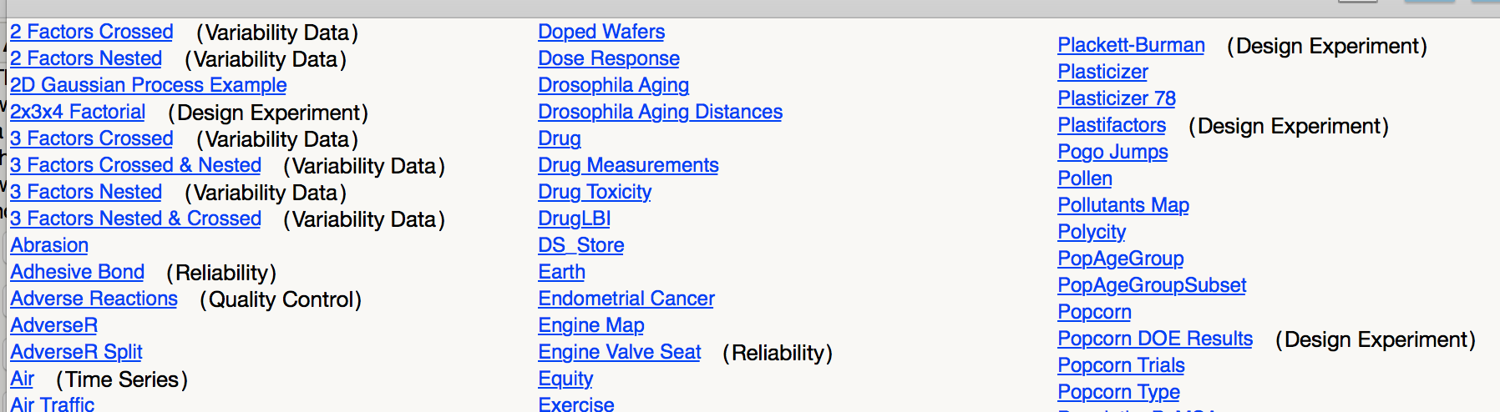
   3. Sample Scripts  
      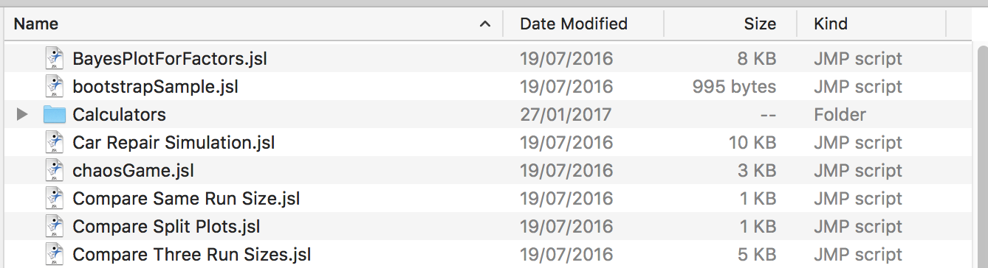
   4. Sample Applications  
      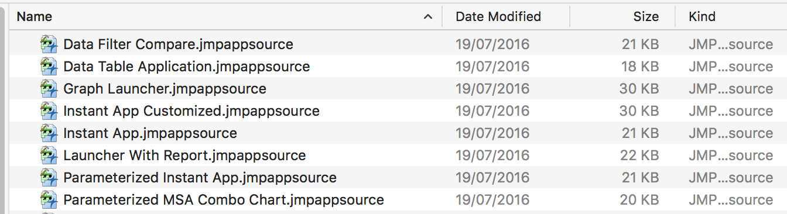  
      Once you double click and open one up, you need to click on the Run Script button to run it.  
      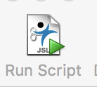
3. Expand the sample files in other areas
   1. Click on some of those links to open tables and explore content  
      